**Department of Electrical Engineering**

|  |  |
| --- | --- |
| **Faculty Member: _________________** | **Dated: ____________________** |
|  |  |
| **Course/Section: BEE 12** | **Semester: Spring 2022** |
|  |  |

**EE-351 Communication Systems**

# Lab2: Balanced Modulator

|  |  |  |  |  |  |  |
| --- | --- | --- | --- | --- | --- | --- |
| **Name** | **Reg. No** | **Viva / Quiz / Lab Performance** | **Teamwork** | **Ethics** | **Software tool Usage** | **Analysis of data in Lab Report** |
|  |  | **5 Marks** | **5 Marks** | **5 Marks** | **5 Marks** | **5 Marks** |
|  |  |  |  |  |  |  |
|  |  |  |  |  |  |  |
|  |  |  |  |  |  |  |

**Lab2: Balanced Modulator**

**Objectives**

* When you have completed this exercise on the balanced modulator, you will be able to describe the circuit, explain its output signal’s relation to the two input signals and describe its operation and application, Also you will use oscilloscope for measurement.

**Lab Instructions**

* The students should perform and demonstrate each lab task separately for stepwise evaluation
* Each group shall submit lab report on LMS within 6 days after lab is conducted. Lab report submitted via email will not be graded.
* Students are however encouraged to practice on their own in spare time for enhancing their skills.
* Complete as many problems as you can within the allotted time.
* Talk to your classmates for help

**Lab Report Instructions**

All questions should be answered precisely to get maximum credit. Lab report must ensure following items:

* Lab objective
* Results (screen shots) duly commented and discussed.
* Conclusion

**Lab 2: BALANCED MODULATOR**

**Exercise 1 – Balanced Modulator**

**EXERCISE OBJECTIVE**

When you have completed this lab exercise on the balanced modulator, you will be able to

* Describe the circuit block
* Explain the output signal’s relationship to the two input signals
* Describe the operation and applications

You will use an oscilloscope to make measurements.

**DISCUSSION**

* The balanced modulator on the circuit board is an IC (1496).
* The circuit consists of dual differential amplifier, differential amplifier, and a current source.
* The output of the balanced modulator is a full wave multiplication of the two input signals.
* The balanced modulator may have a full potentiometer to adjust the amount of modulation or suppress the carrier frequency in the output.
* The balanced modulator’s output will contain the sum and difference frequencies of the input pus the carrier frequency if it is not suppressed.
* The balanced modulator can be used as an AM modulator, an SSB modulator, a mixer, a product detector and a phase detector.

**Exercise 1 – Lab Tasks**

1. Locate an AM/SSB transmitter circuit block on the Analog Communications Circuit and connect the Signal Generator to the M of Modulator. Set Switches S1, S2 and S3 to OFF.

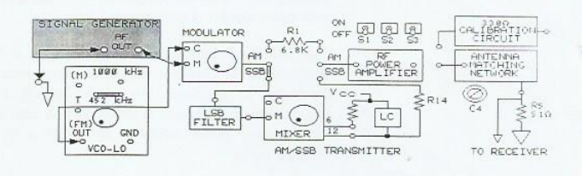

1. Turn the negative supply knob on the left side of the base unit fully CCW to adjust the VCO-LO frequency to less than 452kHz.
2. Connect the oscilloscope of channel 1 probe to the message signal input M to the modulator. While observing the signal on channel 1,adjust the SIGNAL GENERATOR for a 300mVpk-pk, 3kHz sin wave at M.
3. Connect the oscilloscope channel 2 probe to the carrier signal input C on the modulator. While observing the signal on channel 2, adjust the amplitude knob on VCO-LO for 100mVpk-pk at C.
4. Connect the oscilloscope channel 2 probe to the modulators output.
5. Set the oscilloscope vertical mode to channel 2, and trigger n the channel 1. Set the channel 2 attenuation to 500mV/DIV and set the oscilloscope sweep to 0.1ms/DIV.
6. Turn the modulators potentiometer knob fully CCW and then slowly turn it CW until the AM signal is less than 100% modulated.

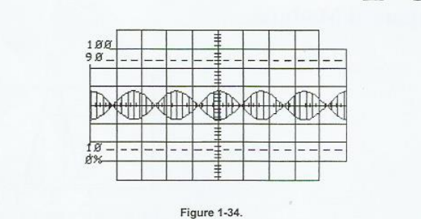

1. Continue to turn the knob slowly CW until the AM signal appears as shown in Figure 1-35. What type of AM modulated signal appears on channel 2: SSB, DSB, or 100% modulated?

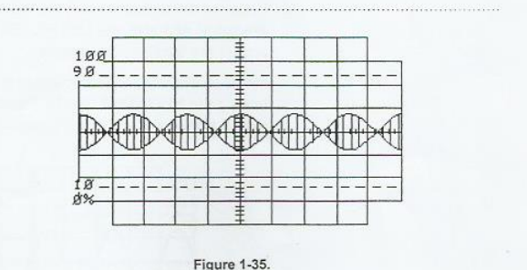

1. If the carrier frequency signal is 452kHz and the message signal frequency is 3kHz, what frequencies would be present in the frequency spectrum of the DSB signal?
2. The LSB FILTER is a narrow-band bandpass filter that passes frequencies between 453kHZ and 457kHz. Any frequencies not in this range are filtered.

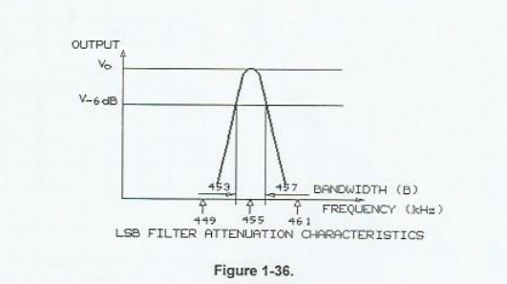

1. Connect the oscilloscope channel 2 probe to the output of LSB FILTER. Set the oscilloscope vertical mode to channel 2, trigger on channel 2, set the channel 2 attenuation to 50mV/DIV and set the sweep to 1us/DIV.
2. Because the frequencies in the DSB signal from the modulator are below 453kHz, THE LSB FILTERS output appears as a trace across the oscilloscope screen.
3. Increase the VCO-LO’s frequency to the modulators by slowly turning the negative suppl knob CW until the LSB FILTERS output signal is maximum.

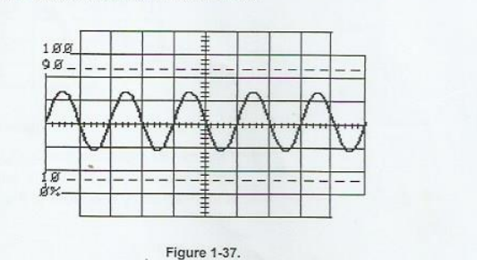

1. What is the LSB FILTERS output signal shown on channel 2: a greater than 100% modulated signal, DSB signal or an SSB signal.

1. While observing the 455kHz signal at the LSB filters output on the channel 2, vary amplitude of the 3kHz message signal to the modulator by varying AF LEVEL knob on the SIGNAL GENERATOR. Does the amplitude of the 455kHz signal very with the amplitude if 3khz message signal.
2. Connect the output of the VCO-HI circuit block to the input of C at the mixer. In the following steps you will observe how a balanced modulator functions as a MIXER to increase the frequency of a signal.
3. Turn the POSITIVE SUPPLY knob on the right side of the base unit fully CCW to set the VCO-HI frequency above 1455kHz.
4. Set the oscilloscope sweep to 05us/DIV. Connect the channel 2 probe to the MIXER’s C input. Adjust the VCO-HI oscillator signal 100mVpk-pk with the potentiometer knob on the VCO-HI circuit block.
5. Connect the channel 1 to the LSB filter output and trigger on channel 1. Connect channel 2 to pin 6 at the MIXER’S output. Set channel 2 to 200mv/DIV.
6. Adjust the MIXER’s potentiometer knob for a DSB signal at pin 6.

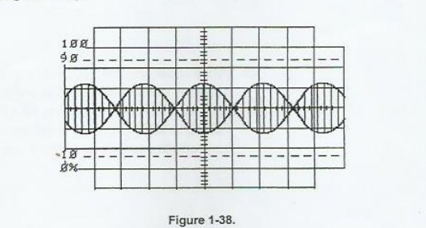

1. Set the channel 2 to 500 mv/DIV and then trigger on the channel 2.Connect channel 2 to pin 12 at the mixer , which is the LC filters output. The signal should appear as a trace.
2. Adjust the VCO-HI frequency to 1455khz by slowly turning the POSITIVE SUPPLY knob CW until the SSB signal at the pin 12 of the MIXER is maximum.

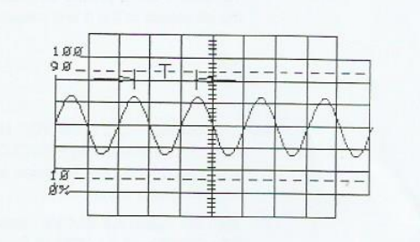

1. Measure the period(T) between peaks of the waveform. Each horizontal division is 0.5us.
2. From the period(T), Calculate the frequency of the SSB at pin 12 of the MIXER.
3. While observing the 1000khz signal at the LC FILTER’S output, vary the amplitude of the 3khz message signal to the modulator by varying the AF LEVEL knob on the SIGNAL GENERATOR. Does the amplitude of the 1000kHz signal at pin 12 vary with the amplitude of the 3Khz message signal.